**6.TrainersApp**

**Step-1: created a trainersapp**

**>npx create-react-app trainersapp**

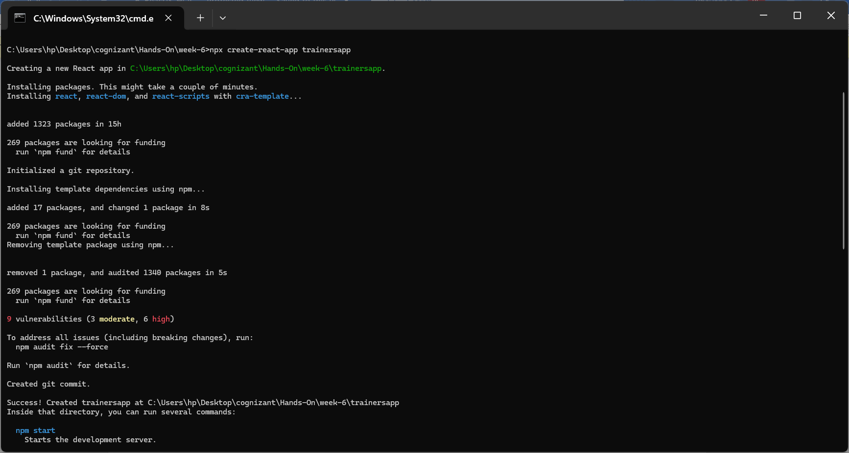

**Step-2: npm install react-router-dom@6**

**Step-3: Open in vscode and modify**

**Trainer.js**

class Trainer {

  constructor(trainerId, name, email, phone, technology, skills) {

    this.trainerId = trainerId;

    this.name = name;

    this.email = email;

    this.phone = phone;

    this.technology = technology;

    this.skills = skills;

  }

}

export default Trainer;

**TrainersMock.js**

import Trainer from "./trainers";

const TrainersMock = [

  new Trainer(

    't-syed8',

    'Syed Khaleelullah',

    'khaleelullah@cognizant.com',

    '97676516962',

    '.NET',

    ['C#', 'SQL Server', 'React', '.NET Core']

  ),

  new Trainer(

    't-jojo',

    'Jojo Jose',

    'jojo@cognizant.com',

    '9897199231',

    'Java',

    ['Java', 'JSP', 'Angular', 'Spring']

  ),

  new Trainer(

    't-elisa',

    'Elisa Jones',

    'elisa@cognizant.com',

    '9871212235',

    'Python',

    ['Python', 'Django', 'Angular']

  )

];

export default TrainersMock;

**trainerList.js**

import React from "react";

import { Link } from "react-router-dom";

import TrainersMock from "./trainersmock";

function TrainerList() {

  return (

    <div>

      <h2>Trainers List</h2>

      <div >

        <ul style={{ listStylePosition: "inside", textAlign: "center" }}>

            {TrainersMock.map((trainer) => (

            <li key={trainer.trainerId}>

                <Link to={`/trainer/${trainer.trainerId}`}>{trainer.name}</Link>

            </li>

            ))}

        </ul>

      </div>

    </div>

  );

}

export default TrainerList;

**TrainerDetails.js**

import { useParams } from "react-router-dom";

import TrainersMock from "./trainersmock";

function TrainerDetails() {

  const { trainerId } = useParams();

  // Find the trainer by ID

  const trainer = TrainersMock.find(t => t.trainerId === trainerId);

  if (!trainer) {

    return <p>Trainer not found</p>;

  }

  return (

    <div>

      <h2>{trainer.name}</h2>

      <p><strong>Email:</strong> {trainer.email}</p>

      <p><strong>Phone:</strong> {trainer.phone}</p>

      <p><strong>Technology:</strong> {trainer.technology}</p>

      <p><strong>Skills:</strong> {trainer.skills.join(", ")}</p>

    </div>

  );

}

export default TrainerDetails;

**Home.js**

function Home(){

    return (

        <h1>Welcome to my Academy trainers page</h1>

    );

}

export default Home;

**App.js**

import './App.css';

import { BrowserRouter as Router, Routes, Route, Link, Navigate } from "react-router-dom";

import Home from './Home';

import TrainerList from './trainerlist';

import TrainerDetails from './trainerdetails';

function App() {

  return (

    <Router>

      <div className="App">

        <h1>My Academy Trainers App</h1>

        <nav>

          <Link to="/home" style={{ marginRight: '10px' }}>Home</Link>

          <Link to="/trainers">Trainers List</Link>

        </nav>

        <Routes>

          <Route path="/home" element={<Home />} />

          <Route path="/trainers" element={<TrainerList />} />

          <Route path="/trainer/:trainerId" element={<TrainerDetails />} />

        </Routes>

      </div>

    </Router>

  );

}

export default App;

**Step-4:**

**Output**

